**Dr Sanjay Kumar Srivastava**

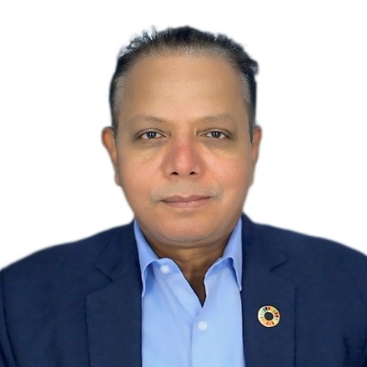<https://www.linkedin.com/in/sanjay-srivastava-53049819/>

Dr. Sanjay K. Srivastava is the S Radhakrishnan Chair Professor at NIAS. He enables undertaking multidisciplinary research, while working primarily with the Energy, Environment and Climate Programme at the institute.

Dr Srivastava has spent over 25 years at the forefront of disaster risk reduction and climate change adaptation across India, South Asia, and the Asia-Pacific.

As Chief of Disaster Risk Reduction at the United Nations Economic and Social Commission for Asia and the Pacific (ESCAP), Dr. Srivastava led the UN’s regional efforts to integrate science, policy, and technology in building resilient societies. Under his leadership, ESCAP’s Asia-Pacific Disaster Report (2010 onwards) and data driven Risk and Resilience Portal shaped high-level intergovernmental negotiations and catalyzed the development of national disaster risk reduction strategies and National Adaptation Plans (NAPs) across the region.

Dr. Srivastava championed regional and sub-regional cooperation to build end-to-end early warning systems—merging cutting-edge impact forecasting, risk modeling, common alerting protocols, and inclusive last-mile outreach to protect the most vulnerable communities.

Before his tenure as Chief at ESCAP, he served as ESCAP’s Regional Adviser on Disaster Risk Reduction (2009-2013), Head of the SAARC Disaster Management Centre in New Delhi (2007/2008), and as Scientist SG/Deputy Project Director of the Disaster Management Support Programme (1991-2009) at the Indian Space Research Organisation (ISRO), where he contributed significantly to the use of space-based technologies in natural resources management, agriculture, rural development and disaster management.

His work has earned him prestigious recognition, including ESCAP’s Innovation Awards in both 2022 and 2024, and ISRO’s Team Excellence Award for applying space technology in 2008–09.

A prolific contributor to global knowledge, Dr. Srivastava has authored over 150 publications and served as lead author of flagship reports such as the Asia-Pacific Disaster Report (UNESCAP) and the State of Climate in Asia and Southwest Pacific (WMO, 2020–2023).

His academic foundation is equally robust, with a Ph.D. in Agricultural Physics from the Indian Agricultural Research Institute (IARI), an M.Sc. in Physics (Electronics) and a B.Sc. (Honours) in Physics from Patna University, and an Executive Certificate in Digital Transformation from Haas School of Business, University of California, Berkeley in 2023.

*******